LAB 2 – Image Processing

* Kunchanapalli Manohar; E18CSE093

RGB to grayscale conversion using matplotlib:

There are 2 methods which we can use to change a rgb image to grayscale.

1. Average Method: We can just simply take the average of all 3 numbers and divide it by 3. But this yield a rather black image not grayscale.
2. Weighted Average Method(implemented): We take some contribution from all colours, and then simply add them up.

Image = (0.3*R + 0.59*G + 0.1140*B) (implemented).

This multiplication converts the image from (x,y,3) to (x,y) thus leading to a grayscale image.

I have multiplied the pixel values of the original rgb image with the weights using numpy library. Then we plot the converted image.

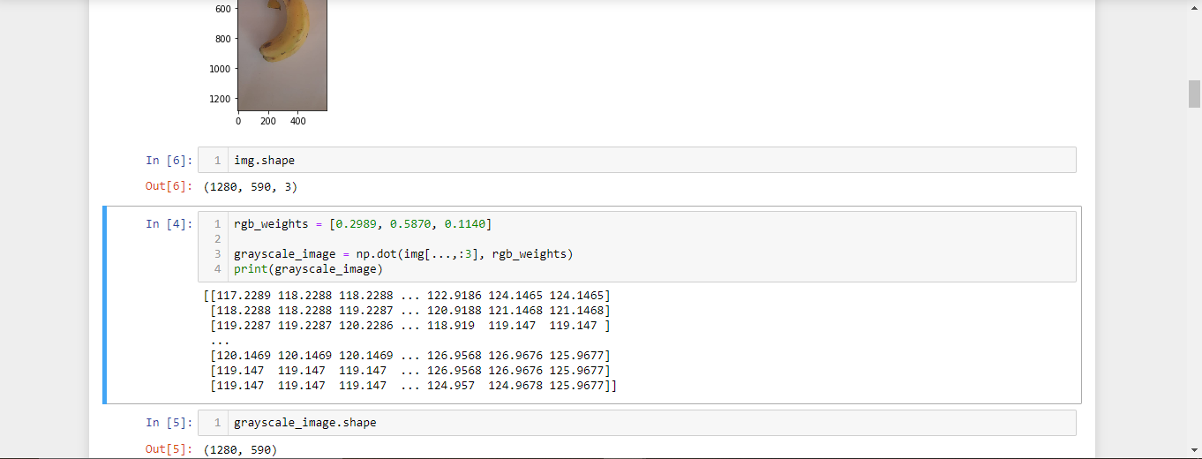

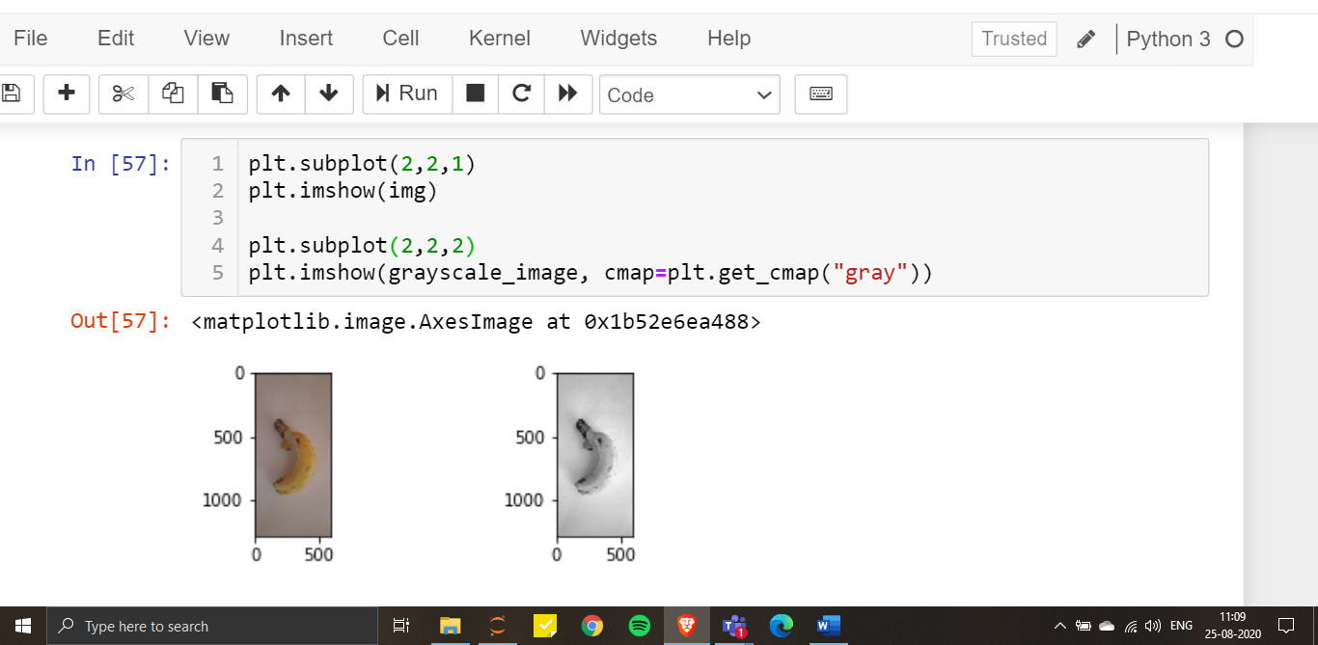

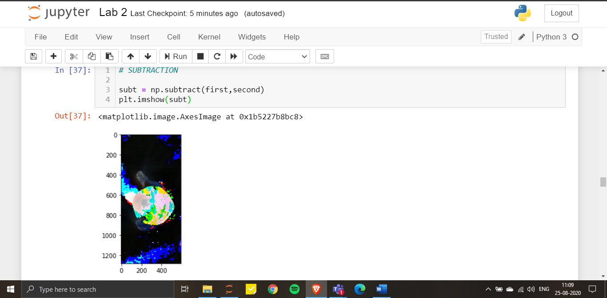

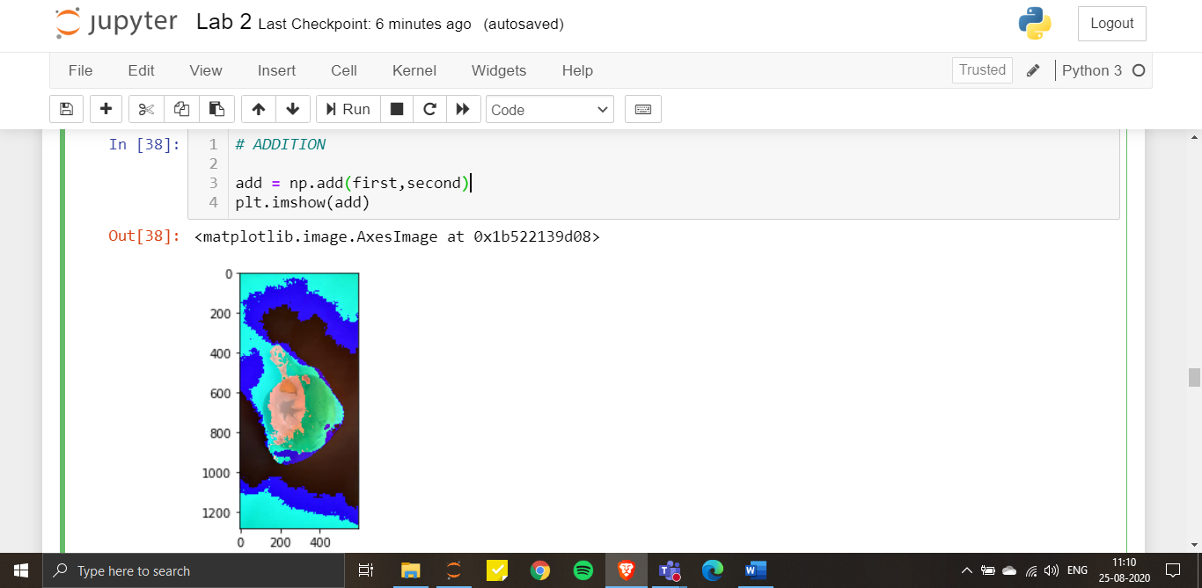

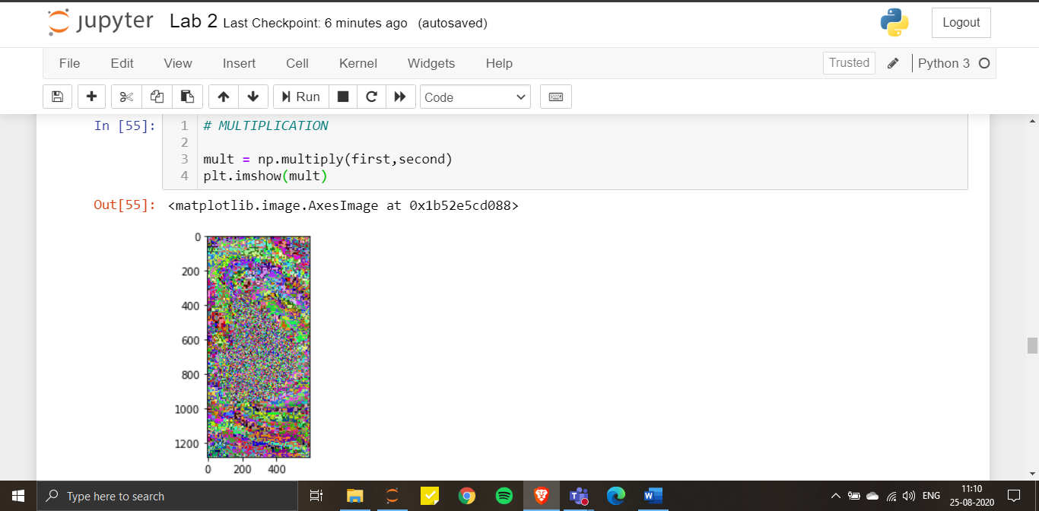

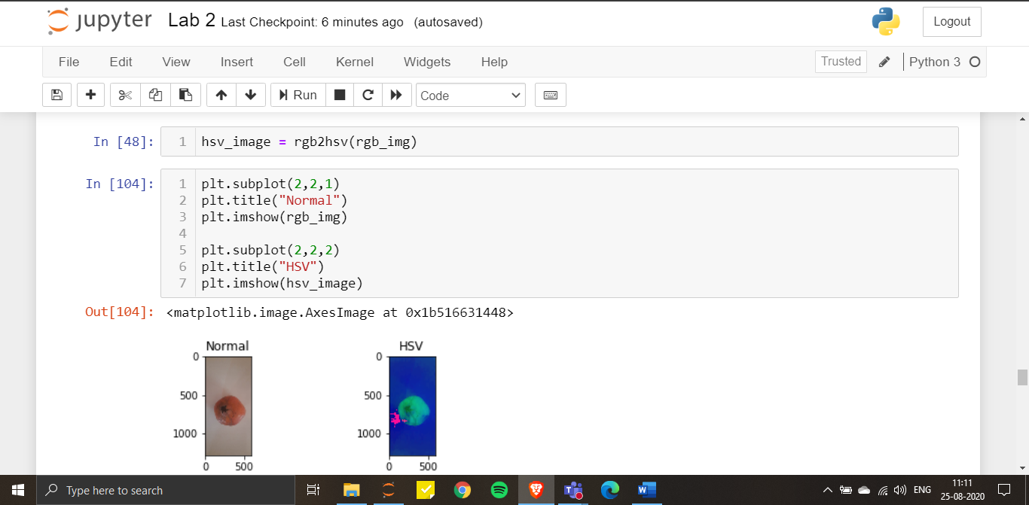

Bilinear Interpolation:

This is image scaling technique. It uses values of only the 4 nearest pixels, located in diagonal directions from a given pixel. This technique considers the closest 2*2 matrix in the neighbourhood of known pixel values surrounding the unknown pixels. A weighted average is taken to arrive at it’s final value.

We simply use openCV library to implement this technique. We use the resize function of cv2 and at the interpolation parameter we put it as cv2.INTER_LINEAR which signifies bilinear interpolation.

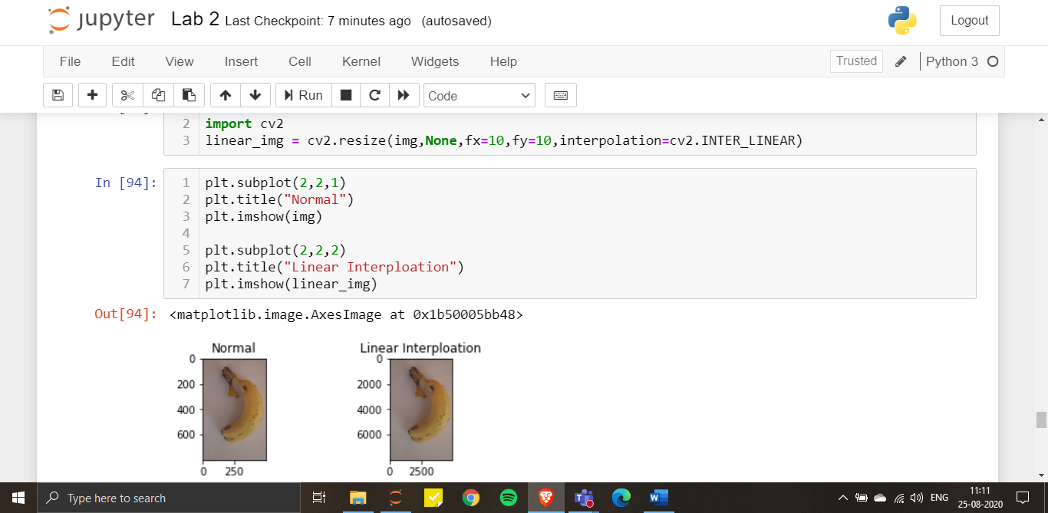

Bicubic Interpolation:

We use this method to preserve the sharpness and details. It takes the values of point on a grid and interpolate it to approximate the value of its surrounding point. Simply put, It uses weighted average of 4 pixels to produce the pixel value of an output pixel

We simply use openCV library to implement this technique. We use the resize function of cv2 and at the interpolation parameter we put it as cv2.INTER_CUBIC which signifies bilinear interpolation.

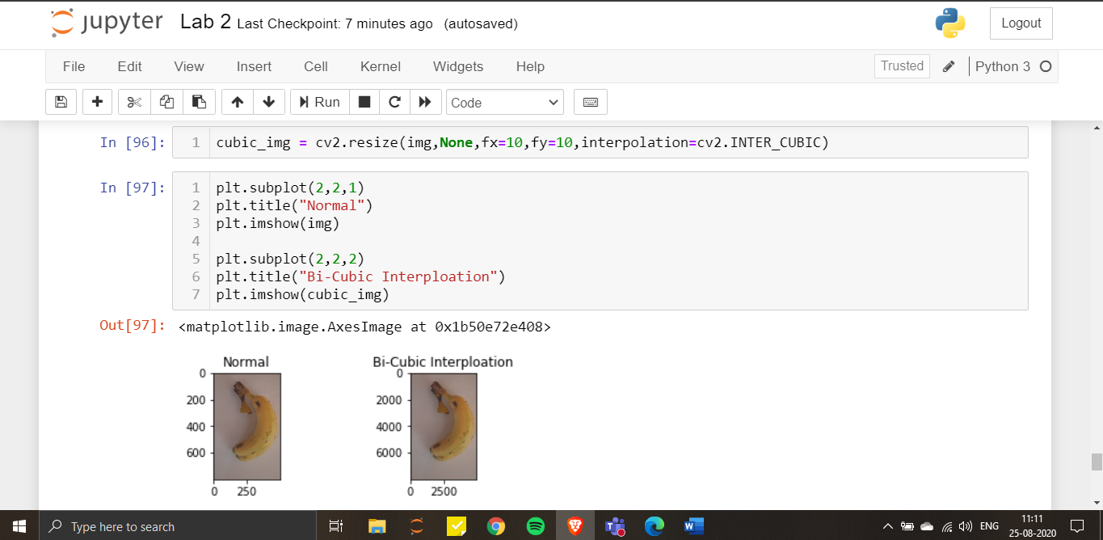

Nearest Neighbour Interpolation:

Rather than selecting values of neighbouring points, this algorithm selects the value of the nearest point to produce the value of a new pixel.

We simply use openCV library to implement this technique. We use the resize function of cv2 and at the interpolation parameter we put it as cv2.INTER_NEAREST which signifies bilinear interpolation.

